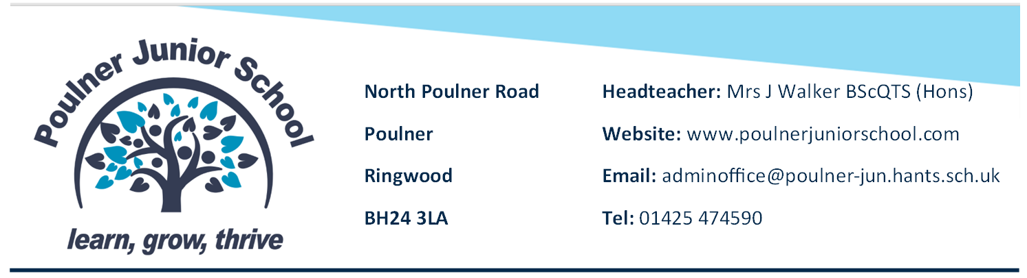

29th October 2026

Site Assistant
We are currently looking for a passionate, proactive individual to join our expanding team as a Site Assistant. Our school premises and extensive landscapes form the very foundation of our daily operations and community identity.
The role will be for 8am to 4pm and would be for 2 or 3 days per week. The role could potentially be term time only.
Grade C (£26,018 to £27,111 FTE)
The role will be to support the Site Manager with the security, cleanliness, maintenance and comprehensive environmental upkeep of the school site.
The assistant site team ensures the absolute structural integrity, security, and day to day functional operations of the main school estate:
1/ SITE SECURITY AND LOCKS
2/ REPAIRS AND DECORATION Act as an authorised primary key holder. Responsibilities include executing precise shift-based opening and lock-up routines, conducting comprehensive security sweeps, checking for vandalism, and addressing out-of-hours emergency alarm calls. Execute planned minor DIY repairs, carpentry, fixtures installation, and routine painting/redecoration projects during holiday down-tomes to ensure all interior classrooms stay fresh and safe.
3/UTILITIES AND OPERATIONS
4/LOGISTICS AND FUNCTIONS Assist with monitoring major utilities (heating, lighting, ventilation, filtration) Conduct daily checks to confirm operations efficiency and report complex maintenance requirements promptly. Support the physical configuration of the school for large-scale events, parent evenings, performances, and physical relocations of classrooms or heavy furniture assets.

QUALIFICATIONS AND TRAINING
Good standard of literacy and numeracy (GCSE English and mathematics Grade C of equivalent preferred) Willingness to complete all mandatory health, safety and trade certifications linted in the training pathway

If you are interested in finding out more about us, you are warmly encouraged to contact us. Please call Jayne Evry on 01425 474590 or email j.evry@poulner-jun.hants.sch.uk and we will be more than happy to answer your questions or tell you more about the role and our school.
This pack and an application form is also available on the school website.



