

You have activities to complete from White Rose but here are some other activities to have a go at which are maths related!

Practice using digimaps before having a go at this task—Follow the link..https://digimapforschools.edina.ac.uk/login and follow the instructions from the digimap tasks which we have also uploaded on separate documents.
username: BH243LA password: scrims0885

You job is to plan a bike ride or walk in the New Forest.

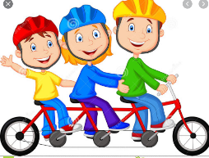
Refer to the guidance page to ensure you have considered all that you need to!

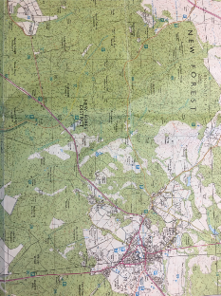
1) Make a list of what you need to consider in order to start planning your route?
2) Now, look at the OS map (download large version), what do you need to know now?

Don’t forget to use revision guides to help you with conversions!
Calculate the distance between two locations by using digimaps or the maps provide on the next pages and use a string or a shoelace or something similar to measure along roads, paths and tracks. Then use a rule to measure the cm and convert to metres, km or miles!
1) Ringwood to Burley.
2) Bransgore to New Milton
3) Poulner to Moors Valley
Now choose some of your own locations.
What about from your house to school? Or your house to a location in the New Forest.

You could also just use the squares on the map to calculate the distance. This is called ‘as the crow flies’

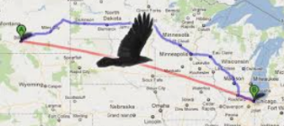

Now, Plan and calculate your bike ride or walk in the New Forest (use digimaps or the map provided for you on the next page)
After, here are some challenges:
⇒ What if you could only travel a Maximum distance of 40km?
⇒ You must travel along set paths (but NO dual carriageways)
⇒ You must start at school and visit 2 other villages/towns as well as Ringwood
⇒ You started at your house?

Create your own ‘what ifs…’

Things to consider for your bike ride:
⇒ distance from start to finish
⇒ Where we are starting and finishing
⇒ Coordinates on map (in case we get lost)
⇒ Our route-will we use roads, tracks and paths?
⇒ The map scale—how far?
⇒ The timing
⇒ Do we need toilets?
⇒ Do we need a lunch stop or breaks? If yes, then where will we stop?


OS map scale: If your using digimaps, you can choose the scale by zooming in or out. You can then see the map scale by clicking on map information.

If your using the maps provided, the scale is 1:50000 = 2cm = 1km
1 map square = 2cm = 1km.
1cm = 50m = 0.5km

As an approximation, 1 mile = 1.6km.
To turn miles into kilometres we divide by 5 and multiply by 8.
To turn kilometres into miles we divide by 8 and multiply by 5.

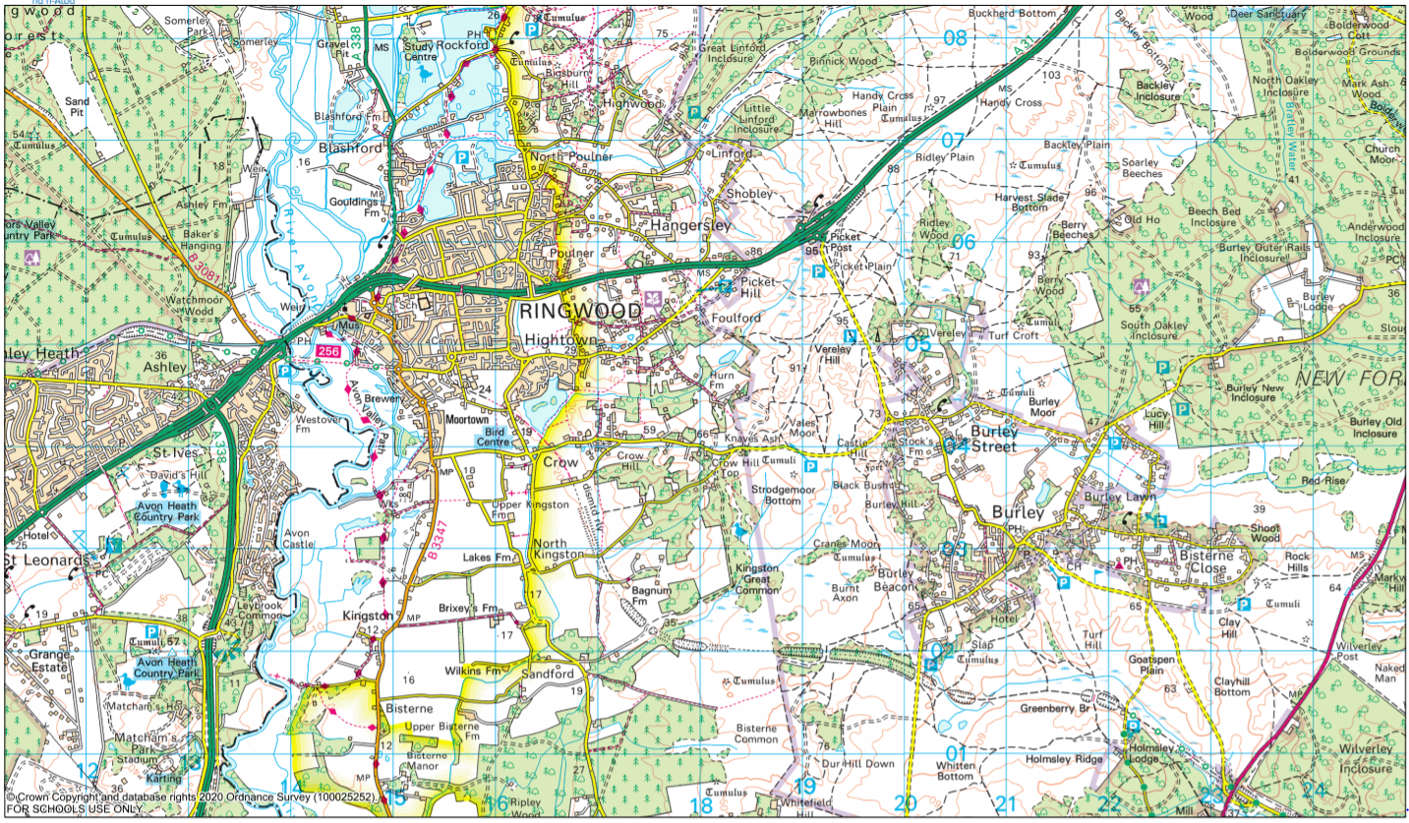
Map scale: 1: 50,000 which means 2cm = 1km.
1 grid square = 1 km!

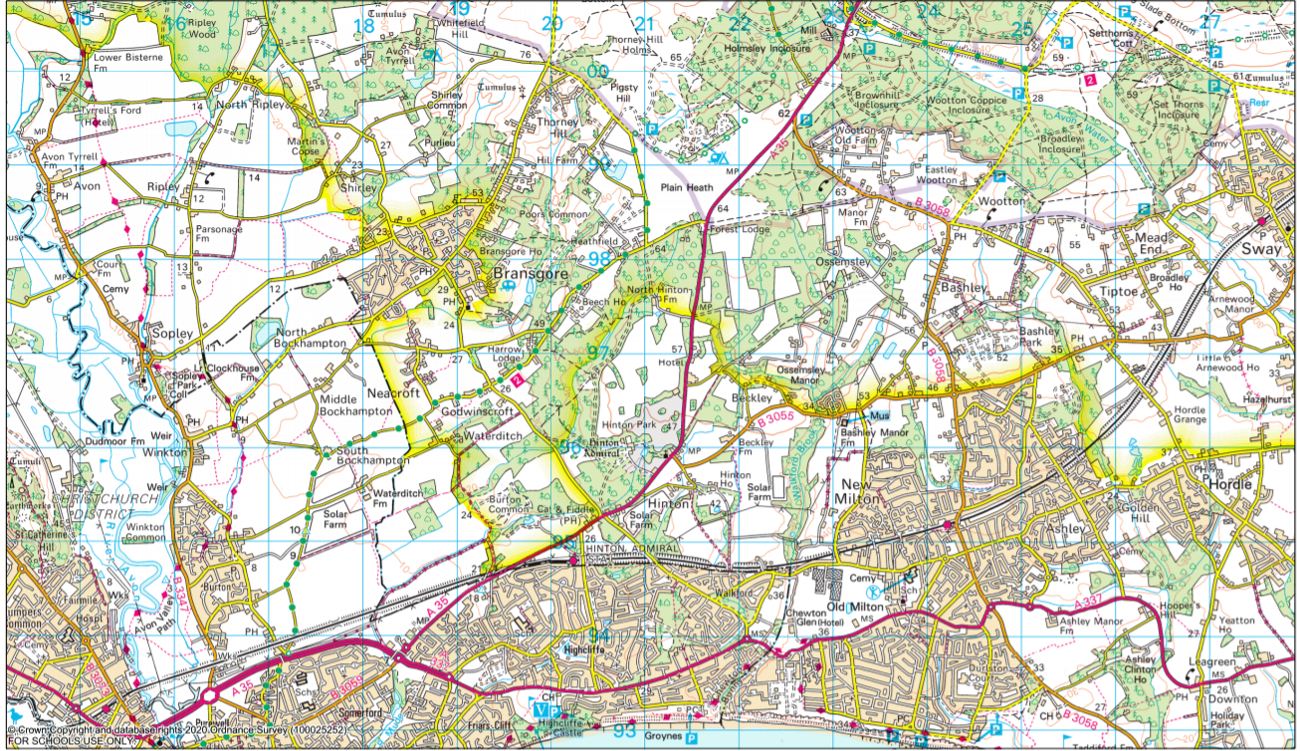
Map scale: 1: 50,000 which means 2cm = 1km.
1 grid square = 1 km!

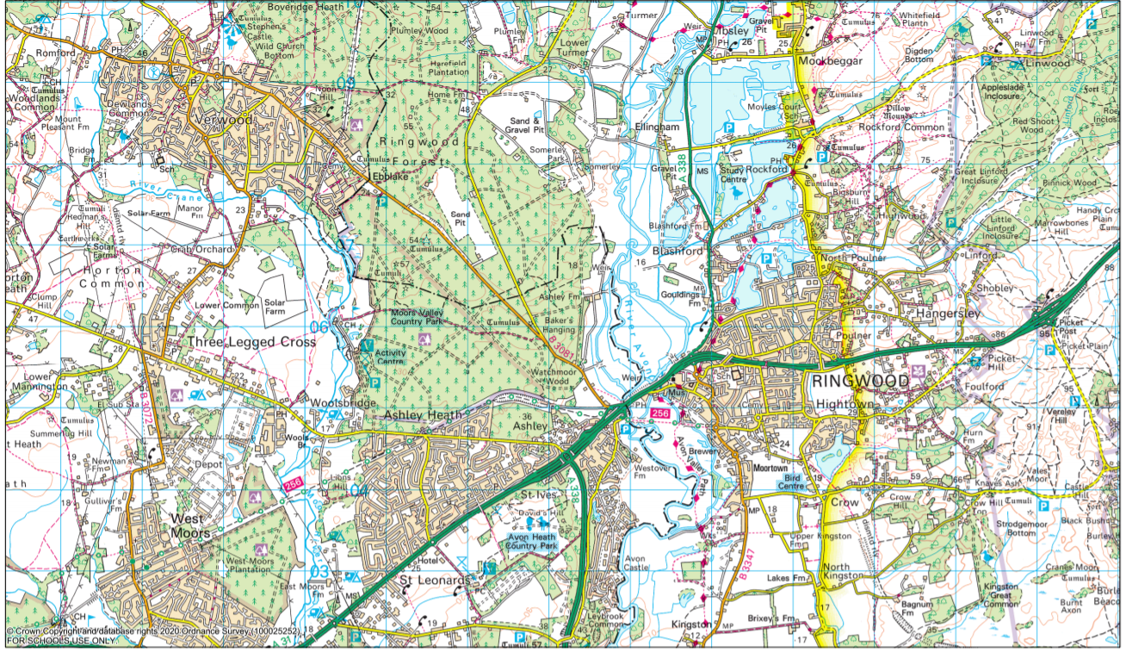
Map scale: 1: 50,000 which means 2cm = 1km.
1 grid square = 1 km!

Objective: | Measurement  Geography link – National Parks. | I can prove I have achieved this.
Skill | I can solve problems involving the calculation and conversion of units of measure, using decimal notation up to three decimal places where appropriate.

Start point | Finish point | Number of grid squares | Total distance KM | Conversion (to miles or/& metres)
Ringwood | Burley
Bransgore | New Milton
Poulner | Moors Valley

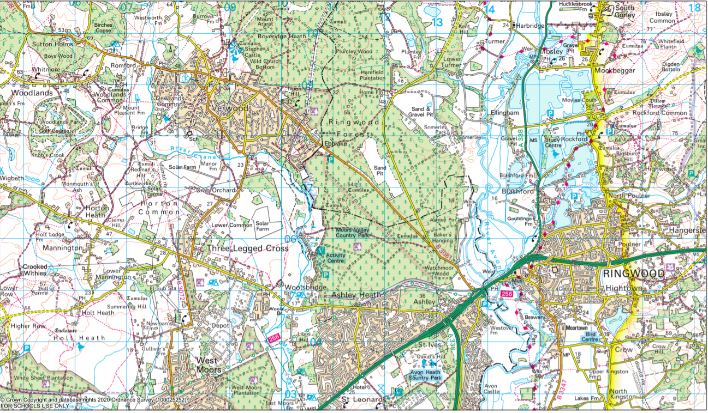

Map scale: 1: 50,000 which means 2cm = 1km.
1 grid square = 1 km!

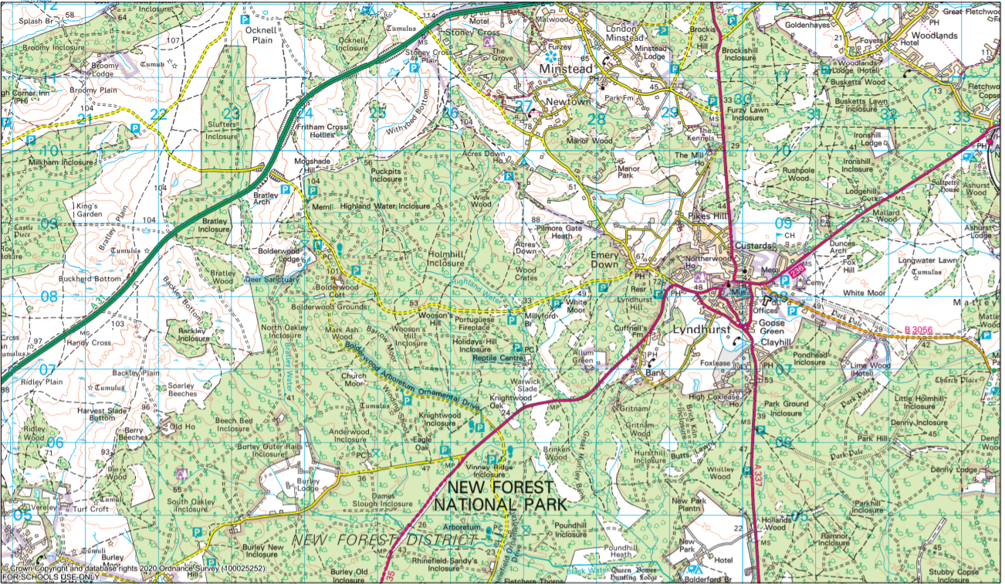

Map scale: 1: 50,000 which means 2cm = 1km.
1 grid square = 1 km!

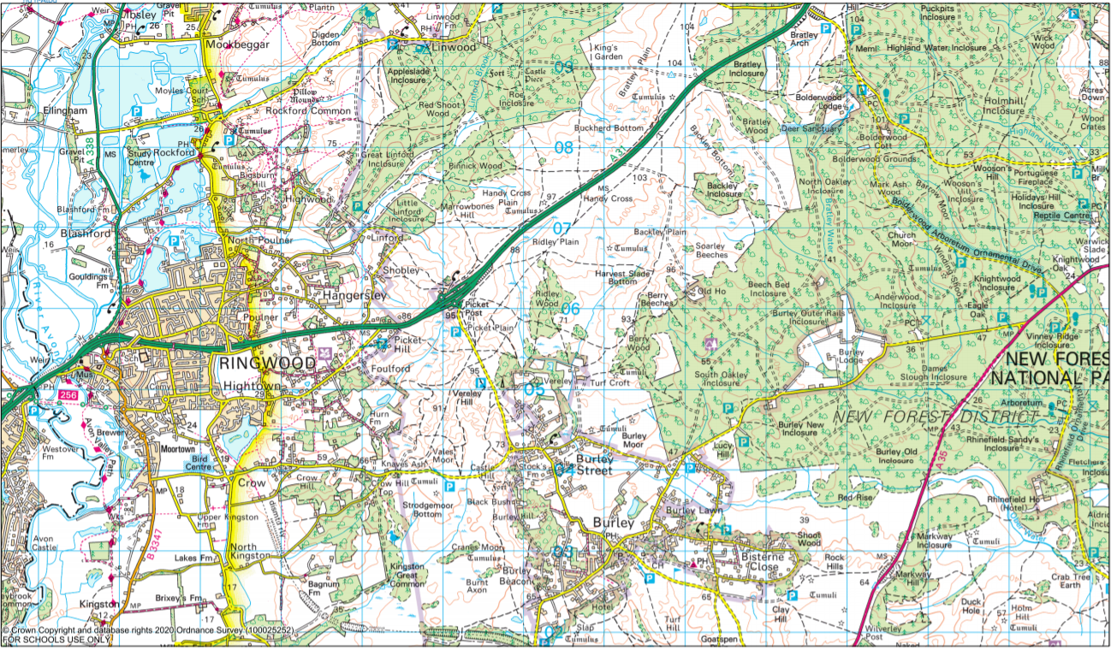

Map scale: 1: 50,000 which means 2cm = 1km.
1 grid square = 1 km!

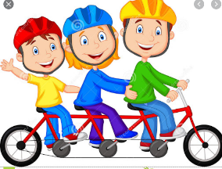
You job is to plan a bike ride or walk in the New Forest.

Things to consider for your bike ride:
⇒ distance from start to finish
⇒ Where we are starting and finishing
⇒ Coordinates on map (in case we get lost)
⇒ Our route-will we use roads, tracks and paths?
⇒ The map scale—how far?
⇒ The timing
⇒ Do we need toilets?
⇒ Do we need a lunch stop or breaks? If yes, then where will we stop?

OS map scale: If your using digimaps, you can choose the scale by zooming in or out. You can then see the map scale by clicking on map information.

If your using the maps provided, the scale is 1:50000 = 2cm = 1km
1 map square = 2cm = 1km.
1cm = 50m = 0.5km

As an approximation, 1 mile = 1.6km.
To turn miles into kilometres we divide by 5 and multiply by 8.
To turn kilometres into miles we divide by 8 and multiply by 5.

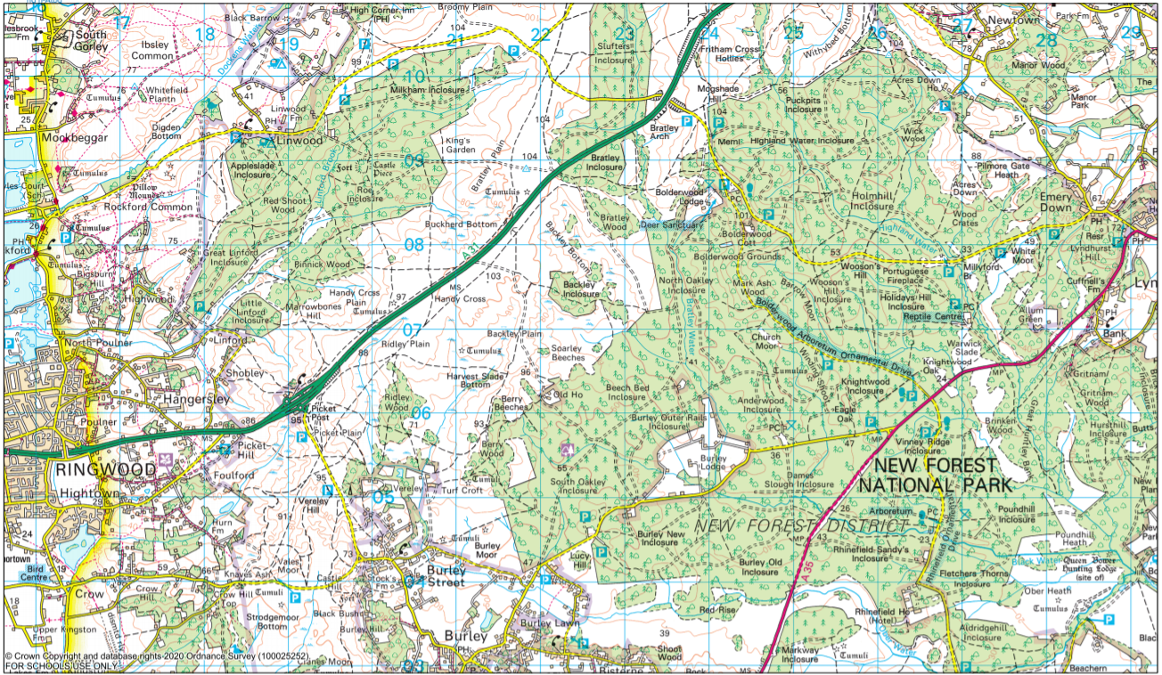
Map scale: 1: 50,000 which means 2cm = 1km.
1 grid square = 1 km!

