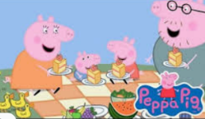
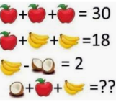
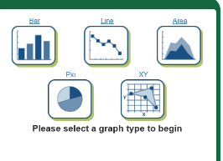


Find the best place to sit at lunchtime.
Measure various factors of four places in the outdoor area such as the sound level, air temperature, ground temperature, distance from football pitch/play area or kitchen. The categories of the factors you measure are up to you
Decide how to record your findings and present your best choice and reasons. Ensure you should include some of the factual information, for example how the ground here is coldest so we don’t want to sit there.
You can also include personal choices based on the facts like “I chose to be close to/far away from the football pitch because…”
Upload this to google classroom so we can compare our findings!
If you haven’t got access to google classroom then record in your green books and prepare to share this when we get back to school!
Plan your family’s weekly food shop and calculate the cost. (you can search the cost of each item online either on a supermarket site or google!
• What would you buy for the family and how much would this cost?
• What if you only had £40 to spend? Or £125?
• What if you planned the meals for each night and then went shopping? Do you save money?
• What are the differences between each supermarket?
Where is cheapest to shop and by how much?
Create a maths game. Upload it onto google classroom or give to your family for others to play!
It could be in the form of a quiz on PowerPoint or a board game style or puzzle!
Get creative!
Using the following website: https://nces.ed.gov/nceskids/createagraph/default.aspx collect your own data and create a graph.
If you haven’t got any internet access then collect data and present it in a graph in your green books.
Possible data to collect: heart rate at different times in the day, the heart rate of family members during Joe Wicks PE, how much sunlight there is over the week, your family members favourite meals. Anything you choose!
Remember to consider the type of graph you’ll use.

A variety of different maths activities for you to have a go at!

