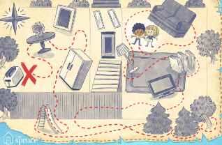
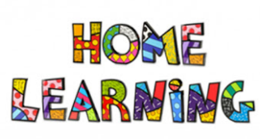

Indoor Treasure Hunt

Distribute the clues so that one clue leads to another and don’t forget to place some "treasure"—a toy or treat—at the final destination.
Make your treasure hunt a workout for the brain with clues that require some thinking. Rhyming clues could also be fun or simply just pictures that you draw or print out from the computer.

Here are some ready-made Clues you might want to use (and the answers on the next page)

- I have four legs, but I don't have feet.
I come in handy when it's time to eat.
- My job is to put an end to sleep,
Which I do with music, a buzz, or a beep.
- For fast heating or cooking, I am tops.
And, oh, that good smell when my popcorn pops!
- I'm packed really full of boxes and cans.
I may hold a broom or a mop or a dustpan.
- Flour and sugar and coffee and tea,
I keep these handy but hard to see.
- I can take you to places you've never seen,
But first type your password in on my screen.
- I'm loaded and unloaded, but I'm not a truck.
Having a helper like me is a great piece of luck.
- I rain on you when you need a scrub.
I'm very much like my friend the tub.
- I make it possible to have fresh food.
Everyone agrees I'm one cool dude.
- Watching your favorites is lots of fun.
But don't watch too much! Kids need to run.
- I never get angry but I do get hot.
I'm the perfect place for a pan or a pot.
- It's my job to give all your clothes a tumble,
Which I do while making a bit of a rumble.
- I have a round knob and also a lock.
Visitors and salesmen may give me a knock.
- I'm one part chair and one part bed.
Up with your feet and down with your head.
- I take your clothes for quite a spin.
But first, they get wet. That's how I begin,
- I'm filled with feathers or other soft fluff.
To sleep without me can be quite tough.
- Turn me on and I'll give you a light.
I'm used some in the daytime but mostly at night.
- A story, they say, can take you away,
But a book still needs a place to stay.
- I have drawers and also a nice flat top.
For homework I'm helpful -- Keep working. Don't stop!
- I'm hungry! I'm hungry! Please feed me a slice.
I'll spit it back out all brown and nice.
- I'm not a selfie, but I do show faces.
Find me in bathrooms and a few other places.
- Adults go here when they first wake
And at other times when they need a break.
- Most every day, you step on me.
All I require is a bend of your knee.
- I go round and round and get really hot.
In larger families, I'm used quite a lot.
- I'm paper, but I'm not used for writing a letter.
The spot by your potty suits me much better!
- I have hands but no arms and also a face.
And my hands always move at the same steady pace.
- I may have eyes but I really can't see.
People love to make fries out of me.
- The more I dry, the wetter I get.
A little one can be used for soaking up sweat.
- I hold all the words you need to know.
Use me to make your vocabulary grow.
- I'm never wicked, but I do have a wick.
I come in all sizes, from skinny to thick

ANSWERS

1. Kitchen or dining table 2. Alarm clock 3. Microwave 4. Pantry 5. Kitchen canisters 6. Computer 7. Dishwasher 8. Shower 9. Refrigerator 10. Television 11. Kitchen stove 12. Clothes dryer 13. Front door 14. Recliner 15. Clothes washer 16. Bed pillow 17. Lamp 18. Bookshelf 19. Desk 20. Toaster 21. Mirror 22. Coffee maker 23. Stairs 24. Clothes dryer 25. Toilet paper 26. Clock 27. Potato 28. Towel 29. Dictionary 30. Candle

