ACTIVITY | DESCRIPTION / RULES
‘The Slalom’  (Dribble)  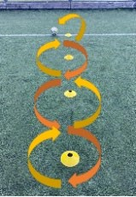 | You will need: A ball, 4 markers, a stopwatch  - Set 4 markers out in a straight line that are 1m apart  - On the command ‘Go’ the participant dribble in and out of each cone and back.  - Every completed slalom back to the start cone is 1 point. ● 2 minutes to gain as many points as possible.  How many slalom’s can you do in 2 minutes?  Easier: markers 0.5m apart Harder: markers 1.5m apart
8-metre Dash (Running with  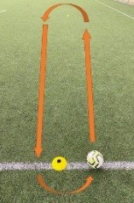  the  Ball) | You will need: A ball, 2 markers, a stopwatch ● Set 2 markers out that are 8 metres apart.  - Start behind on of the markers  - On the command ‘Go’, the participant runs with the ball around each marker.  - Every completed ‘end’ is 1 point  - 2 minutes to gain as many points as possible.  How many runs can you do in 2 minutes?  Easier: 5 metre distance Harder: 10 metre distance
Rebound Race (Passing)  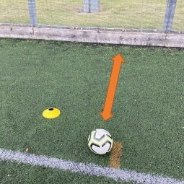 | You will need: a wall, a ball, a stopwatch  - Place the marker 1.5 metres away from the wall  - On ‘Go’, the participant passes the ball against the wall.  - Every pass against the wall is 1 point.  - Encourage participants to control the ball before each pass. ● 2 minutes to gain as many points as possible.  How many passes can you score in 2 minutes?  Easier: 1 metre distance Harder: 2 metre distance/use both feet
Aiming Accuracy (Passing Target)  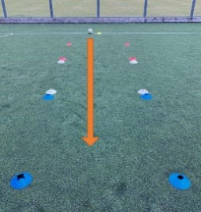 | You will need: a ball, 13 markers  - Use 4 markers to create a ‘target’ area (2 metre square)  - Use a marker to designate where to pass from and create the 3 target area 2m, 4m, 6m away  - Using different types of passes try and hit each target area – the ball doesn’t have to remain in the target area.  You have 10 attempts to hit the target as many times as possible – can only pass through each target once on each attempt  - 2m target hit = 1 point, 4m target hit = 2 points, 6m target hit = 3 points ● Record the score – Max 30 points available  Easier: 3 metre square ‘target’ Harder: 1 metre square ‘target’
Knockdown  Challenge  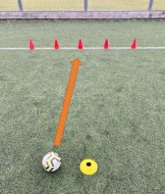  (Shooting) | You will need: a ball, 5 marker, 5 targets (bottles/cans etc), if possible a football goal.  - Place the 5 targets evenly spread across the goal line 0.5m away from each other if possible.  - Place the starter marker 2m away from the goal line, then the other 4 markers a metre further back each time.  - You have 1 attempt from each marker to knock down a target  - 2m – 1 point, 3m – 2 points, 4m – 3 points, 5m – 4 points, 6m – 5 points Record your score – Max 15 points available.  Easier marker 0.5m away. Harder: marker 2m away.
ACTIVITY -Athletics | DESCRIPTION / RULES
Shuttle Run  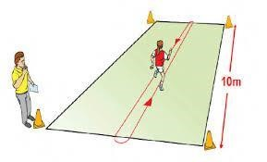 | - Set 2 cones out that are 5m apart • This will create the running lane.  - On the command ‘Go” the athlete runs the 5m distance a total of 12 times for Year 3/4 pupils and 16 times for Year 5/6 pupils to complete the equivalent of 60m or 80m.  - Record the score using a stopwatch or smart phone How quick did you manage to run those laps?
Vertical Jump  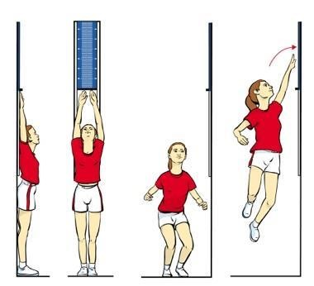 | - The participant stands with their back and heels touching the wall.  - Both arms should be stretched upwards and legs straight.  - The printed scale provided should be stuck on the wall and a mark made where the top of the fingers reach when fully stretched.  - Turn side on, move 20cm away from the wall, jump and touch the scale at the highest point.  - You can also use a long ruler or tape measure to measure the difference between the finger tips when stretched up and the jump height achieved  How high did you manage to jump? Record the number reached and calculate the difference between stretched height and jumped height.
Agility Run  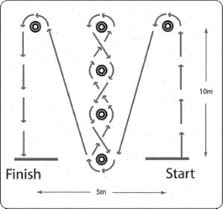 | - Mark out a start and finish area that are 5m apart width ways  - From the start line place a marker 10m away from it and then do the same for the finish line  - In the middle of the start and finish lines place 4 cones in a line to act as a slalom  - On ‘Go’ the athlete runs up to the first cone and goes around it before running back towards the first of the middle cones  - Go around the cone and then go in and out of the remaining cones and copy on the way back  - Lastly run to the cone opposite the finish line go around it  - Stop the watch when the athlete crosses the finish line How quick did you manage to run it?
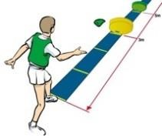Target Throw | - The participant stands behind a line and throws three items into the target placed at 3m.  - The target is then moved to 5m and the process is repeated.  - 4 points if the item lands in the target.  - 2 points if the item bounces out of the target or if the item touches the floor before the target  How many points did you manage to get in 6 throws?
Highland Steps | - Step over the wedges one foot followed by the other so both feet have impacted with the floor in each section.  - Follow the sequence 1, 2, 3, 4 for 30 seconds.  - Both feet must land in each section of the Highland Steps Mat.  - If the participant stands on the wedge then they can either return to space number one or the space before the error occurred and continue.  - If they do not and continue the cycle will not count.  - 1 point for 1 cycle (1, 2,, 3, 4) finished in the correct sequence.  How many points did they get after 30 seconds? (only count full cycles)
  1 | 2
  3 | 4

Cross country activites
ACTIVITY | DESCRIPTION / RULES
Star Run | - Place 8 markers in a star around a central point. The radius should be 10-15m  - Starting in the middle, run out to one marker and back to the middle. Repeat to each marker making sure you go round each marker.  How long did it take you to complete the 8 runs?
Race | - Place 8 markers in a star around a central point. The radius should be 10-15m ● Year 3/4 Time how long it takes to run a 1000 m course.  - Year 5/6 Time how long it takes to run a 2000m course  - Where possible to be run on a flat course grass. If the grass area is not suitable please use a hard court/playground.  Yr 3/4: How quickly can you run 1000m?  Yr 5/6: How quickly can you run 2000m?
Hurdler  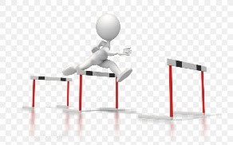 | - Set up a course of about 400m with 6 – 8 barriers in it.  - Pupils have to run the course going over the barriers as quickly as possible.  - Increase the length of the run or number of barriers to make it more challenging.  Who can run it the fastest?
Varied Pace Running | Place down 4 cones to create 4 corners of a box. The distances between cones is 20m. Pick a start point.  - Run all 4 sides  - Run 3 sides Sprint 1  - Run 2 sides Sprint 2  - Run 1 side Sprint 3  - Sprint all 4 sides  How long it takes to complete the circuit?
Relay | - Teams of 2 boys and 2 girls (where possible).  - Year 3/4 and Year 5/6 will be running the same distances as in the “Race” activity  - Where possible run on a flat course grass – if you need to use shuttles or laps then you can.  Year 3/4: How long does it take to run 1000m course? All athletes run 250m  Year 5/6: How long does it take to run 2000m course? All athletes run 500m

