ACTIVITY |  | DESCRIPTION / RULES - Basketball
Count the Bounce 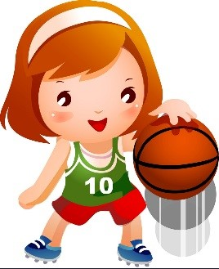 |  | In pairs, bounce the ball in different ways. When your partner is bouncing the ball it is your job to count how many bounces they can complete before losing control of the ball. Types of bounces:  - Bounce using two hands  - Bounce using right hand only and then left hand only  How many times can you dribble in right hand? Now try left hand?  How times can you dribble the ball from each hand (left to right) in 60 seconds?  Progression: Bouncing the ball as above, but can you do that between your legs in 60 seconds?
Bounce On  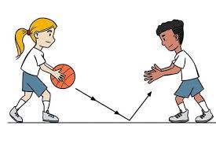 |  | Working in pairs; stand 2m apart, with a marker spot in the middle of you both. Pass the ball to each other as many times as you can without dropping it.  Types of passes:  - Chest pass  - Bounce pass  - Overhead pass  How many can you do in 45 seconds?  Progression: Make the marker spot smaller. Move 3m apart.
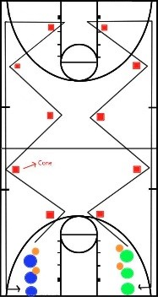  Dribble Relay |  | - Split into two teams of 6  - Each teams places six cones about 2m apart  - Children number themselves 1,2,3 and so on  - On “GO!” number 1’s dribble the ball (with your dominant hand), weaving through the cones and back  - Chest pass or bounce pass to the next child and repeat until all have gone  - Time each team, how it long it takes to complete?  Progression: use your non-dominant hand only.
Spots Shooting  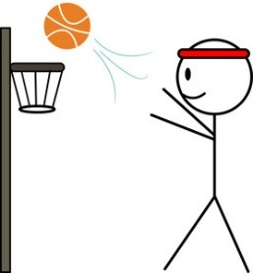 |  | - Split into small group of 8  - Place marker spots or cones, different distances and places around the “hoop”  - Children assign each spot a number value, high numbers for those more difficult to shoot (8 being the hardest, 1 the easiest)  - Children pick a spot to start from and shoot at the hoop, they get that value if they make the shot – children move around all the spots and attempt to shot from each  - How many points can each child get?  Progression: How many points can you get in 60 seconds?  *if you haven’t got a basketball hoop – a tripod basket or hoop on the floor is perfect
Countdown Pass  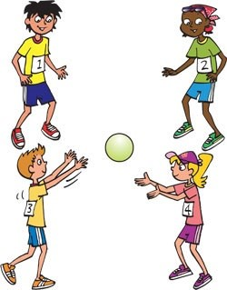 | - Children make circle  - Ball can be passed in any direction, using either a bounce or chest pass  - Children pass the ball to each other around/across the circle  - After 15 seconds, time keeper blow the whistle and the person with the ball is out (they can help with timing and scoring)  - Time keeper stops the game after 90 seconds – all players left remaining get a point • All children back in – and game starts again.  - Play 10 rounds  - How many points can each child get?

Activity | COACHING POINTS - Multi-skills
Agility Obstacles | - Lay out 4 cones in a line, 1m apart. Then 3 cones horizontal at the end 1m from last cone. Year 5/6 have 5 cones horizontal.  - Starting at the first cone. You must weave in and out of the cones  - Once you get to the end, go and touch one of the 3 cones in front  - Run back to the start and repeat  - You must touch ALL cones (one at a time) How quickly can you do it?
Cross the swamp | - Have two markers 5 metres apart  - Grab yourself two hoops or two flat markers  - The aim is to cross the swamp, but you can only stand either in your hoops or on markers.  How many times can you cross the swamp in 45 seconds?  Remember – do not throw hoop/marker too far in front, otherwise you will not be able to reach it to help you across the swamp.
Target Throw 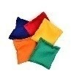 | - Place a hoop 5 metres from your starting point  - Have next to you 5 bean bags  - On go throw the bean bags one at a time into the hoop  - If you miss the hoop, go and collect it and have another go  How long does it take you to throw all 5 bean bags into the hoop?
Beat the Clock  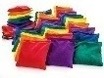 | - Place a hoop 5 metres from your starting point  - Have next to you a 20 items (cones/bean bags)  - Pick up one item, run as fast as you can and place item in hoop. You must place in hoop – not throw  - Run back and pick up another item  How many items can you place in hoop in 30 seconds?
Sideways Stepping | - Have 5 cones in a line, one metre apart  - To complete this exercise you must move side ways  - Starting on cone one, sidestep to cone two. Touch the cone with your foot - Sidestep back to cone one, then sidestep to cone three.  - Back to cone one, then side to cone four  - Back to cone one, then sidestep to cone five  - Back to cone one  How quickly can you do it?

ACTIVITY | DESCRIPTION / RULES – Hockey Upper School only
Dribble Sprints | You will need: 5 cones, 1 hockey ball, a stopwatch  • Set up a 10x10 grid with a hockey ball at each corner. Place a cone in the centre
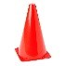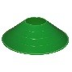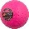  START  1  2  4  3 | of the square.  - This event will have a time as the score  - Each participant will dribble the ball from the middle start cone. Dribble up and around the 1st cone then back to the middle.  - Then to 2nd 3rd and 4th  - When they finish the 4th then stop the clock  How quick did you manage to complete the square?
Precision Passing | You will need: 4 cones (2 different colours), 1 hockey ball, a stopwatch  - Using 2 cones (green) set up a passing gate with the cones ½ metre apart.  - In pairs, pass the ball as many times as possible through the gate in 1 minute.  - Pairs should stand 10 metres apart. (5 metres from centre)  - Increase or decrease the size of the passing gate to make it easier or more difficult  How many times did you pass through in one minute?
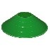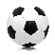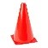  Sink the Ship | You will need: 4 cones (3 of 1 colour, 1 of a different colour), 3 large balls (e,g footballs), hockey balls  - Place 3 footballs/basketballs on cones roughly 2 metres apart  - The idea of the game is to knock every ball off the cones in as few shots as possible. (In any order) How many shots did it take?
Dribble, Shoot, Score!  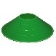 | You will need: 4 cones to dribble through, a goal (or different colour cones), at least 1 hockey ball  - This part of the competition will use all of the skills in the previous activities.  - Students need to be in groups of 4  - 6 cones should be placed at a metre interval.  - At the end of the cones, you will need a goal, if you don’t have a one then use cones. The goal should be 5 metres from the cones (increase if this is too easy)  - Participants should dribble between the cones be careful to go in between each one before shooting at the goal  - If they miss, they need to retrieve the ball and shoot again until they score.  - Stop the clock when all 4 players have completed twice.  How quick did the team manage to complete it?
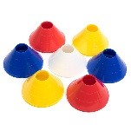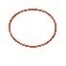Collect-a-Cone | You will need: 4 hockey balls, 4 hoops, 30 - 40 cones  - Place the cones to make a 15 x 15 grid (min)  - Scatter the cones inside the grid  - Students need to be in teams of 4  - The idea of the game is to get as many cones back in your teams hoop  - Students will take it in turns to run into the grid dribbling the ball. Once you have dribbled the ball to a cone, pick it up and dribble back and place the cone in the hoop. Then the next player has a go.  - When all of the cones are collected count them up to see which team wins.  - 1st 4 points 2nd 3 points 3rd 2 points 4th 1 point. Which team has the most amount of points?

ACTIVITY | DESCRIPTION / RULES - Panathlon
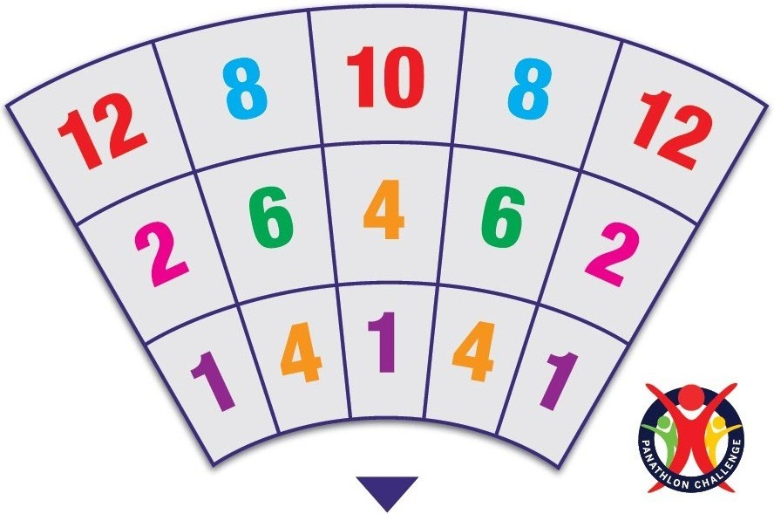  Bean Bag | Objective: Throw a beanbag into various scoring zones on a mat Rules  - Players throw from a seated position, 4 or 5 bean bags each  - The scoring zones are numbered.  - Only one bean bag can be counted per zone • Score where the bean bag finishes up / rests.  - Involve players one at a time  - Continue until the time is up, players can have another go if time.  Scoring: The overall team score is: “The Best Score” + “The Worst Score” = Team  Score
Kurling Sliders  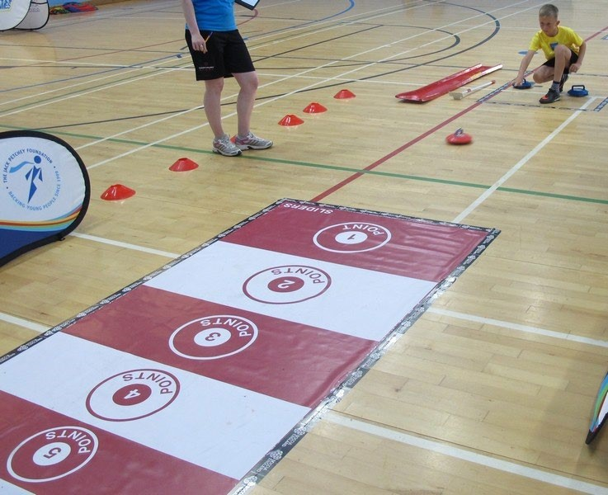 | Objective: Propel the stone onto a target to score points Rules:  - Each player has 3 stones  - The target contains scoring zones, 1-5 , If a stone ends up in-between 2 scoring zones, score highest number  - Add the score of the stones ONLY after all 3 stones have been pushed • Wheelchair players can use a ramp Extra Rule:  - Place a different coloured stone outside the target, at front, next to the 1 score. This can be pushed on the target for double points.  Structure of Game:  - Involve players one at a time  - Continue until the time is up  Scoring: The overall team score is: “The Best Score” + “The Worst Score” = Team Score
Messi Football Skills  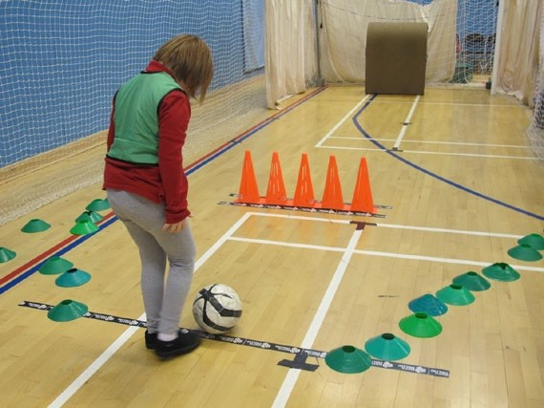 | Objective: Dribble a football through the cones then score a goal  Rule  - The player runs through a set of cones controlling the ball, then shoots for goal.  - Score the number of goals for each team  - For Wheelchair Users: Either Play with a Power chair Football, or, hold the football and throw it to score.  Structure of Game:  - Involve players one at a time.  - Continue until the time is up, players can have 2nd, 3rd goes etc.,  Scoring: Total number of goals scored during the allotted time.

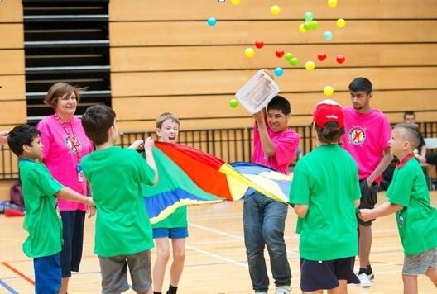  Parachute Popcorn | Objective: To throw balls off a parachute then collect them all in a bucket as quick as possible.  Rules  The balls start in the middle of the parachute  - Players knock the balls off parachute, start the clock  - They need to collect the balls & put them in the bucket (involve a leader to count the balls back in)  - Once all the balls are back in the bucket, stop the clock  - If the team contains a wheelchair player, give the team a -3 seconds bonus per wheelchair user Structure of Game:  - The whole team plays together, all holding the side & handles of the parachute  - Play a number of games, until they’re too tired / had enough. Then play either parachute games with them, or, let them relax under the parachute etc.,  Scoring: Count just the team’s fastest time.
Flight Path  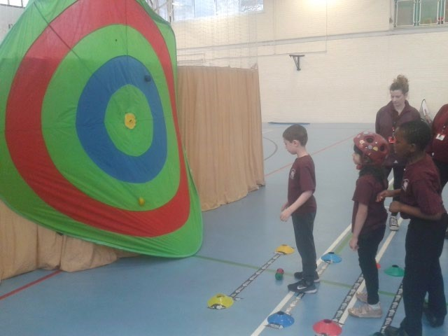 | Objective: To throw a ball onto the target finishing on colours that match the ball. Throw from different distances.  Rules  Player can underarm or overarm the ball on to the target  - The player has 4 throws with 1 yellow, 1 blue, 1 red & 1 green ball.  - 4 throwing lines - different distances  - They need to match the colours of the ball to the colour on the target.  - Score from where the ball sticks or hits the target  - If the player cannot throw, they can use a boccia ramp / come closer if needed.  Structure of Game:  - Involve players one at a time  - Continue until the time is up, players can have 2nd goes etc.  Scoring: For ease, score how many times they get ‘4 out of 4’ and ‘3 out of 4’
Basketball Team Game  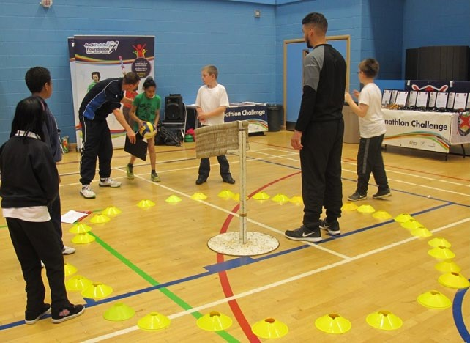 | Objective: Throw the ball in the hoop as many times as possible, within a minute  Rules  - Everyone is involved  - Must throw from outside the cones  - Players can enter the cones to get the ball back  - Can use Ramp, for those who cannot throw.  Structure of Game  Continue until the time is up  - One leader to count as hoops are scored  - A second leader watched the time, call out at “30 seconds”, then count from 10 seconds to 1  - Give the group another to try to beat their score.  - Re-adjust the cones to their correct place for each new team.  Scoring: Record highest number of hoops scored.

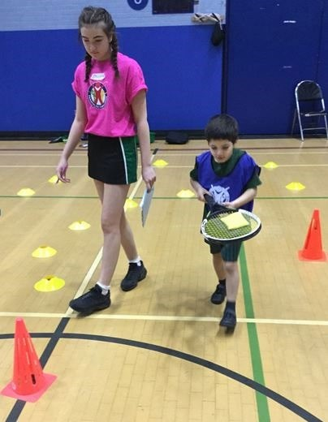  Slalom | Objective: Navigate around a slalom course whilst balancing a bean bag (then tennis ball) on a tennis racket (not bouncing the ball) Rules:  - Timed event, add 3 seconds to time if bean bag / tennis ball drops off  - Teachers can walk with the children Structure of Game:  - Continue until the time is up  Scoring: The overall team score is: “The Best Time” + “The Worst Time” = Team  Score
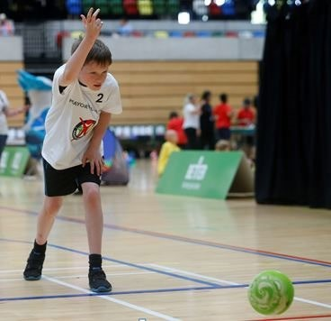Ten Pin | Objective: Knock over as many skittles as possible in the allotted time Rules:  - 10 skittles in a line  - 1 throw per player  - Remove each knocked over skittle  - Wait until all the skittles have been knocked over, then replenish all 10 skittles back on the line Structure of Game:  - One player at a time  - Continue until the time is up, players can have 2nd goes,  Scoring: Add the total number of skittles knocked over.

