
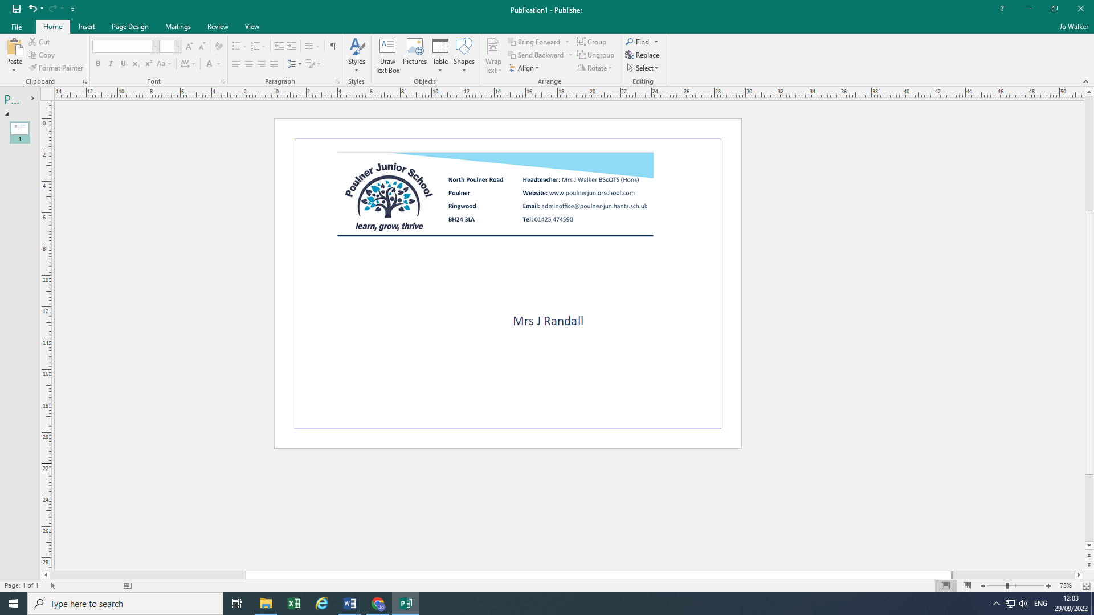
19th May 2026

Dear Parents/Carers
Poulner Infant School Transition for Year 3 September 2026
Welcome to Poulner Junior School! We are delighted that your child will be joining us in September and that you have chosen us to guide and support your child through their next four years of education.
We know that for both you and your child moving school is a big jump and it is important that the transition into juniors is a smooth and well-informed process. Below I have given you a timeline of events that will be taking place for you and your child over the coming months and I hope you can join us for a Parent/carer information evening on Monday 8th June from 6.00- 7.30pm.
This will be a chance for you to meet the leadership team, the Year 3 team that will support your child in September and a chance to learn more about the school and our approach to working in partnership with you. Educatering, our in-house kitchen team and school uniform suppliers will also be attending the event.
We are very aware that Year 2 are still focusing on completing their Year 2 learning, so the transition program has been composed carefully to ensure that there is plenty of opportunity for your child to visit, whilst enjoying their last half a term at infants.
Program of transition:
- Year 2 will receive a buddy letter from the Year 3 junior children straight after half term.
- 10th June- Assembly with Mrs Randall and stay and play (10-10.45am)
- 22nd June- Story time with their new teacher based at Poulner Infants (2.30-3pm)
- 17th June and 24th June- Meet your new teacher, small group meeting on the school field (3.30pm-4pm) Child and parent/carer to attend. If your surname is A-N please come to 17th June, if your child’s surname is M-Z then please attend 24th June.
- 29th June- Transition Day- Moving up- Year 2 will spend the day with us and their new class teacher. They will arrive at the school for 9.00am and be collected at 3pm. Further details will be explained at the information evening.
- 1st July- Treasure hunt – Year 2 and Year 3 joint activity at the juniors (9.30-11.45am)
- 10th July- Meet and play at the infants (10.15-11.00) Year 3 to meet up and answer any questions that the Year 2 children may still have.
We know that some children will find the change more of a challenge than others and we will be working with your child’s school to identify who may need further visits in a more personal visit. If your child’s school feels that this would be of benefit, then they will liaise with you directly to inform you of the additional visits.

Shortly, you will also be receiving several electronic forms and information regarding your child’s admission, permissions, medical and personal information. We appreciate your promptness in returning these once complete. If you would like support to complete any of the forms then please do let us know, we are happy to help.
Finally, we know that some children will be excited, some nervous and feeling that change is a tricky obstacle to navigate. I want to reassure you that our journey together begins now and where needed we can add in additional visits and meets. If you would like to speak with us or just like further details clarified, then please do book a time to meet with us or find us on the gate on a morning. The morning gates are staffed by the leadership team including myself, Mrs Cason- the Deputy Headteacher and Mrs Smalley- the Pastoral Lead and we are always happy to stop to talk and listen.
Yours sincerely
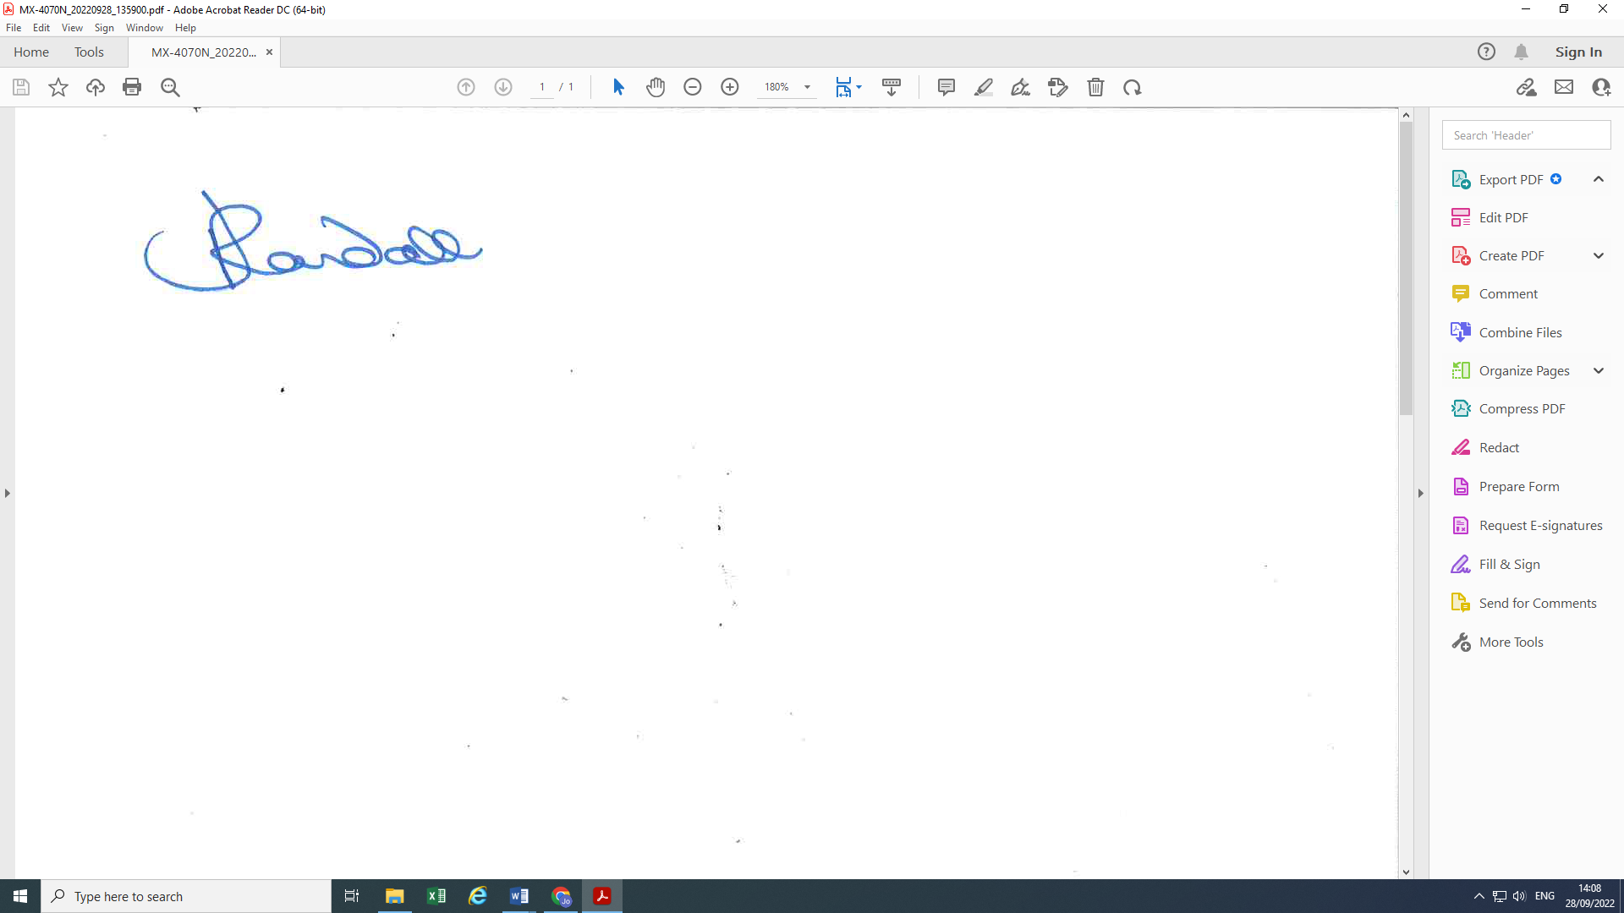
Mrs J Randall
Headteacher



