

Dear Parents/ Guardians,
Poulner ‘Walk to the Well’
Sponsored event
Thanks to your very kind donations, we have collected, sorted and stored over 1000kg of pre loved school uniform and shoes. The next big task is to raise the funds to ship it all to the orphanage in Kisumu, Kenya. For those on Instagram- please follow our progress @poulner_to_kenya
During the week commencing Monday 22nd November, your child will be taking part in a ‘Walk to the Well’ event, in which they will be walking/ running each day to simulate a typical week for a Kenyan child. The children will be aiming to ‘Walk to the Well’ each day and as school we will add up how many times we complete this challenge. The children in Kisumu have to walk approximately 1 mile in order to get fresh water from the well. For those who would like an additional challenge, they can carry some additional weight to signify the bringing back of the water! All children who take part will receive a certificate for their achievement.
We would like the children to be sponsored by family and friends for the effort that they are going to put in. Please find attached a sponsor form for your child. We hope that you see this a worthwhile cause and that you will support us in our aim to improve the lives of countless children in Kenya.
All funds raised will be shared 50/50 with the school, the school using their half to help and improve the school for our children here at Poulner and more importantly the other half will go directly to the shipping costs, so that our old uniform can reach its new home. We are aware that this is close to Christmas and we really appreciate all of the funds that you are able to raise in support of this amazing project.
Please can sponsor forms and money be handed in to class teachers on the day or via the Just giving link on the sponsorship form or shown below.
Thank you so much for all your support!
https://www.justgiving.com/crowdfunding/help-send-uniform-to-kisumu?utm_medium=email&utm_source=ExactTarget&utm_campaign=20211015_
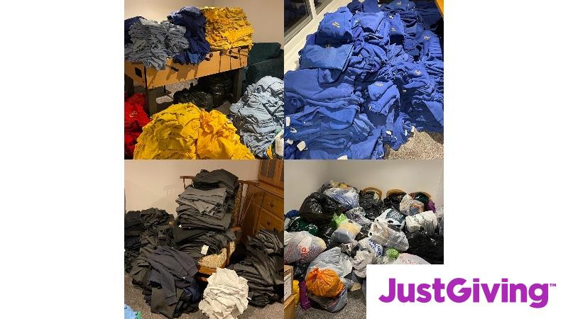 | Help raise £5000 to send pre loved school uniform and school shoes to an orphanage and surrounding villages in Kisumu, Kenya.  Weʼre raising money to send pre loved school uniform and school shoes to an orphanage and surrounding villages in Kisumu, Kenya.. Support this JustGiving Crowdfunding Page.  www.justgiving.com

‘WALK TO THE WELL’
SPONSORSHIP FORM
Date of Event- Monday 22^{nd-} 26th November 2021

Name of Child _________________________________ Class _______________________

Name of Sponsor | Amount | Paid?

Total raised £ ___________________________

Thank you so much for all of your effort and sponsorship.
Please return form and money on the day of the event or via the Just giving link below.
https://www.justgiving.com/crowdfunding/help-send-uniform-to-kisumu?utm_medium=email&utm_source=ExactTarget&utm_campaign=20211015_

