
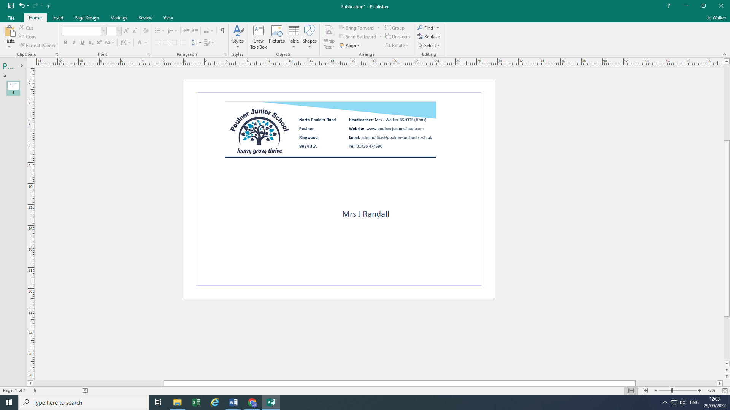
11th May, 2023

19th June, 2023

Dear Parents/Carers,

Year 5 Camp update

Due to the ongoing hot weather, we have decided to make some amendments to the Year 5 hike to ensure the children’s health and wellbeing. We will now be hiking to Blunts Barn, pitching our tents and participating in some outdoor learning activities at the site rather than hiking back to school. The children can then be picked up from the centre at 3.45 pm to allow any parents to collect their children from school first. As the site has limited parking capacity, we would be grateful if parents could arrange lift sharing where possible.
The children can then return for the evening activities and overnight camp at 6pm. Pick up will be at 9am the following morning. The address for the venue (3 miles from the school) is:
Blunts Barn Activities
Blunts Barn, Furzehill,
Fordingbridge, Hants, SP6 2PT
If you have any questions or concerns, please do not hesitate to talk to one of the Year 5 teachers.
Many thanks,

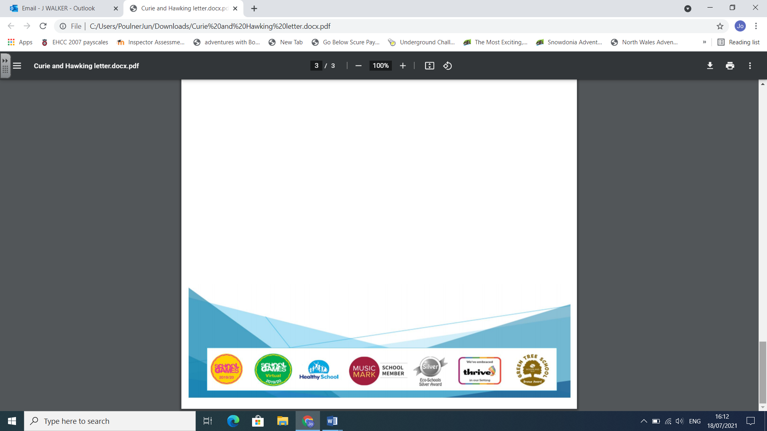
Emma Merrills

