
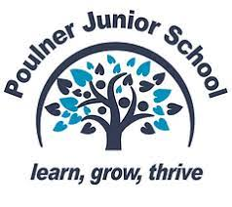
Reading and Writing at PJS
At Poulner Junior School, we want our children to become life-long readers. One of the greatest gifts we can give them is a love of reading. We therefore strive to ensure all children leave us with the skills to read fluently and with a good understanding – as well as a love of books!

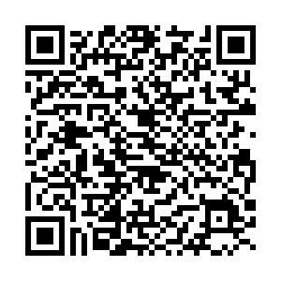
‘More than any other subject, English – and especially reading – gives
pupils access to the rest of the curriculum and is fundamental to their educational success.’ (Ofsted, 2022)
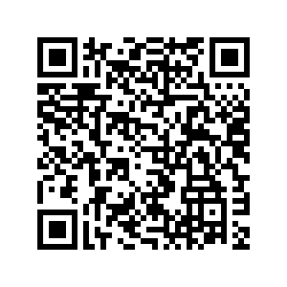
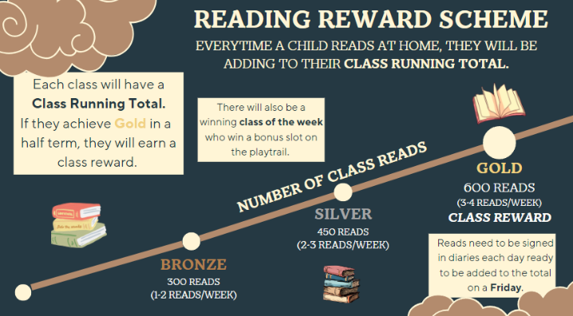
DfE Reading Framework, July 2023

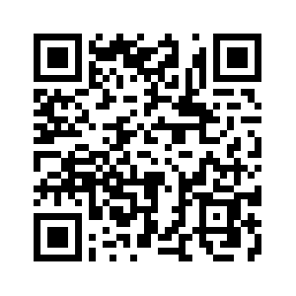
Why Reading Matters – Rita Carter

The Healing Power of Reading – Michelle Kuo

James Durran – Re-thinking Success Criteria
It is important to teach about genre and about the features of different kinds of writing. But teachers know that, when pupils move on from thinking just in terms of text type, their writing opens up, with much more potential for richness, variety and authenticity.

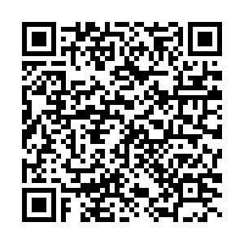
So traditional ‘success criteria’ are really the wrong way round. They define
‘success’ in terms of the presence of ingredients, not in terms of the actual
point of the writing.

The boxed criteria keep the ingredients, but link them explicitly to purpose and to the reader. It’s really that simple. In the middle, pupils put what the writing is and its intended audience; outwards from this are the intended ‘effects’ on that audience, or what the writing is meant to provide for its readers; outwards again are the ingredients – the features which might help to achieve these things.
James Durran Blog

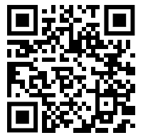

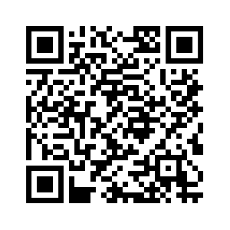


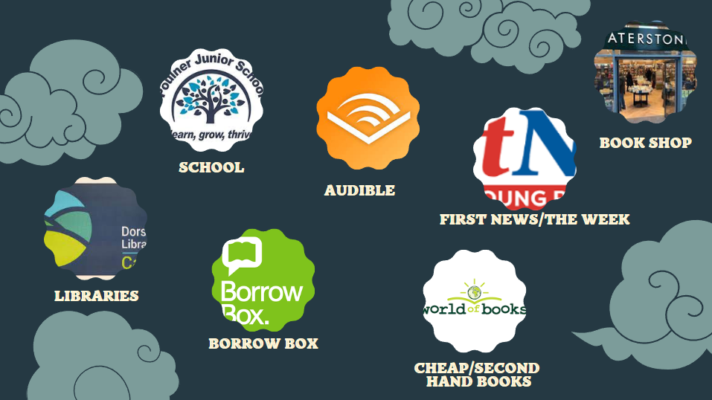
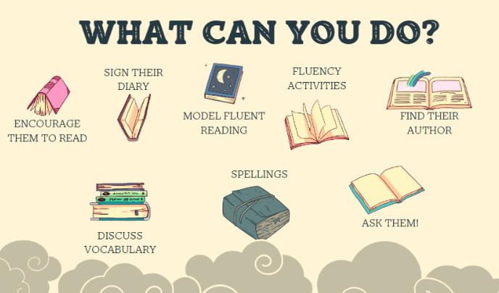

The Week
First News
Fluency activities
World of Books
Borrow Box

